**CL-1002**

**Programming Fundamentals - Lab**

**Lab # 4**

|  |
| --- |
| **Objectives:**   * Introduction to Visual Studio 2015. * Debugging * Step Through Code * Break Points * Practice tasks |

**Note: Carefully read the following instructions (***Each instruction contains a weightage***)**

1. Use proper **font family** and **font size** of **heading**, **sub heading** and **normal text**.
2. First think about statement problem then write/draw your logic on copy.
3. Write pseudocode of every task on **paper (hard form)**.
4. File tittle should in proper format (**23F-1001-Lab2**)
5. Do not copy from any source otherwise you will be penalized with negative marks.
6. Complete your lab **within given Time Slot**.

* Press Windows key and type “Visual Studio”
* Start new project

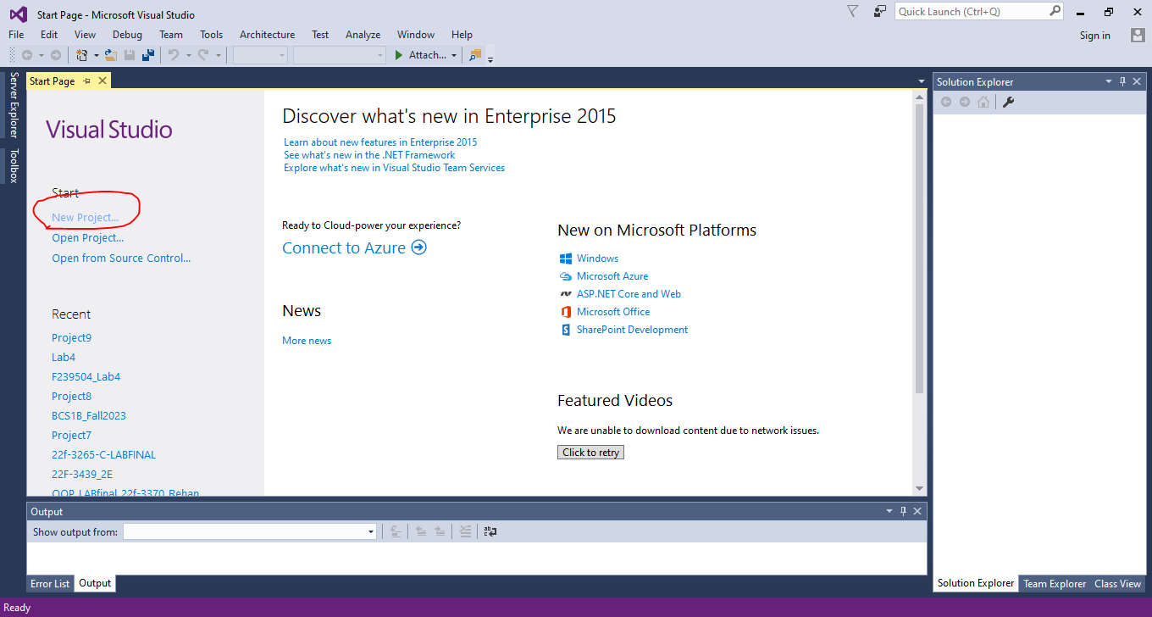

* Now select empty project for visual C++

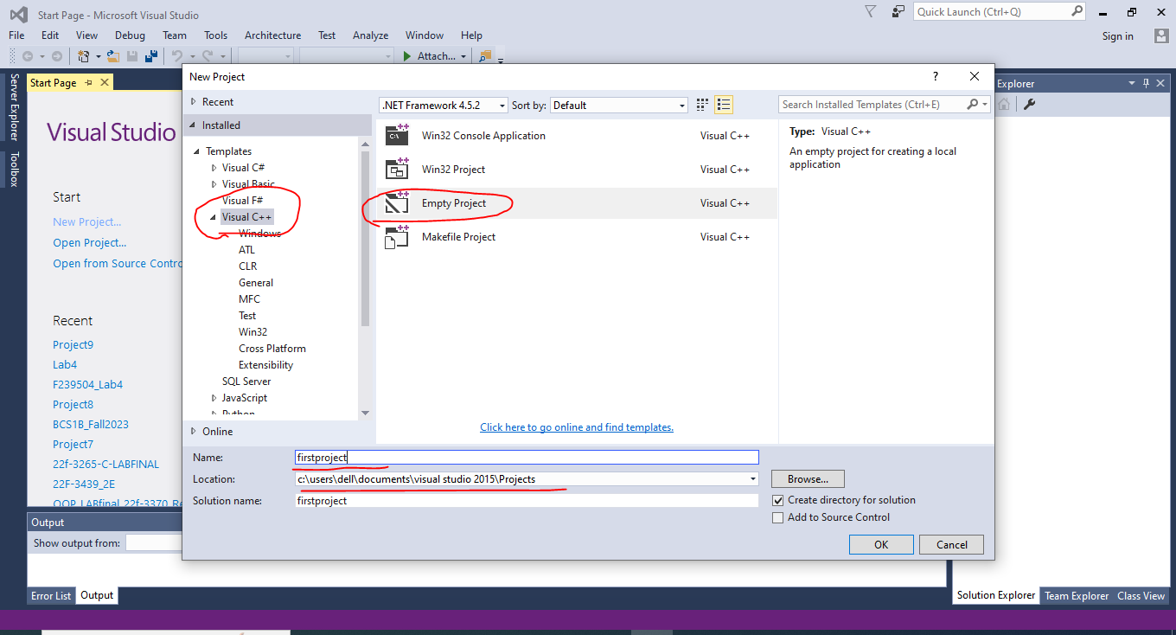

* Choose appropriate name and location for that project
* Right click on source files, then select Add and select New item

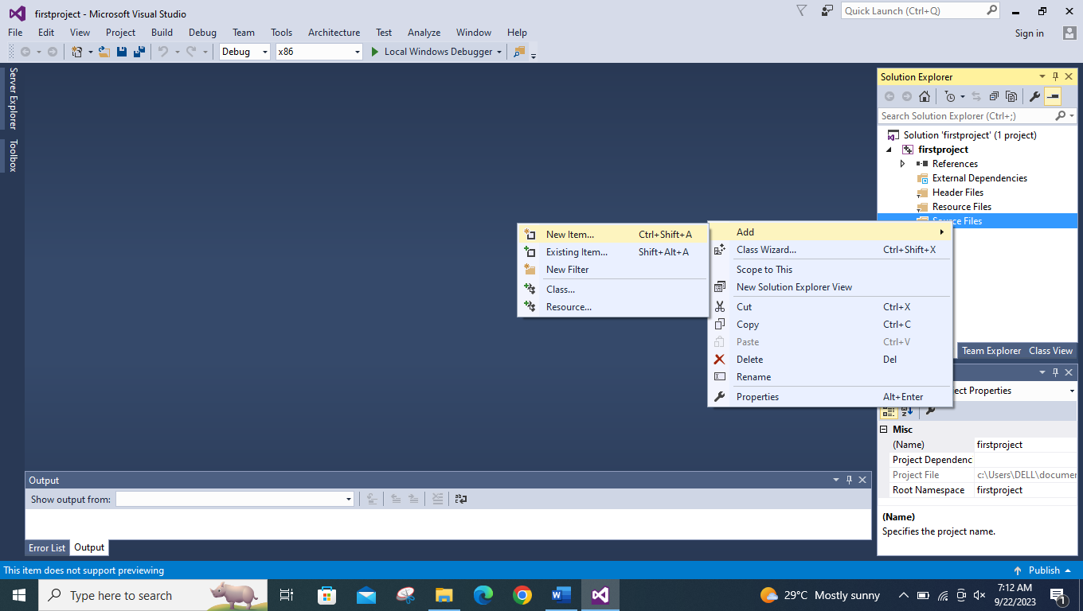

* Then select C++ source file (.cpp) and choose appropriate name

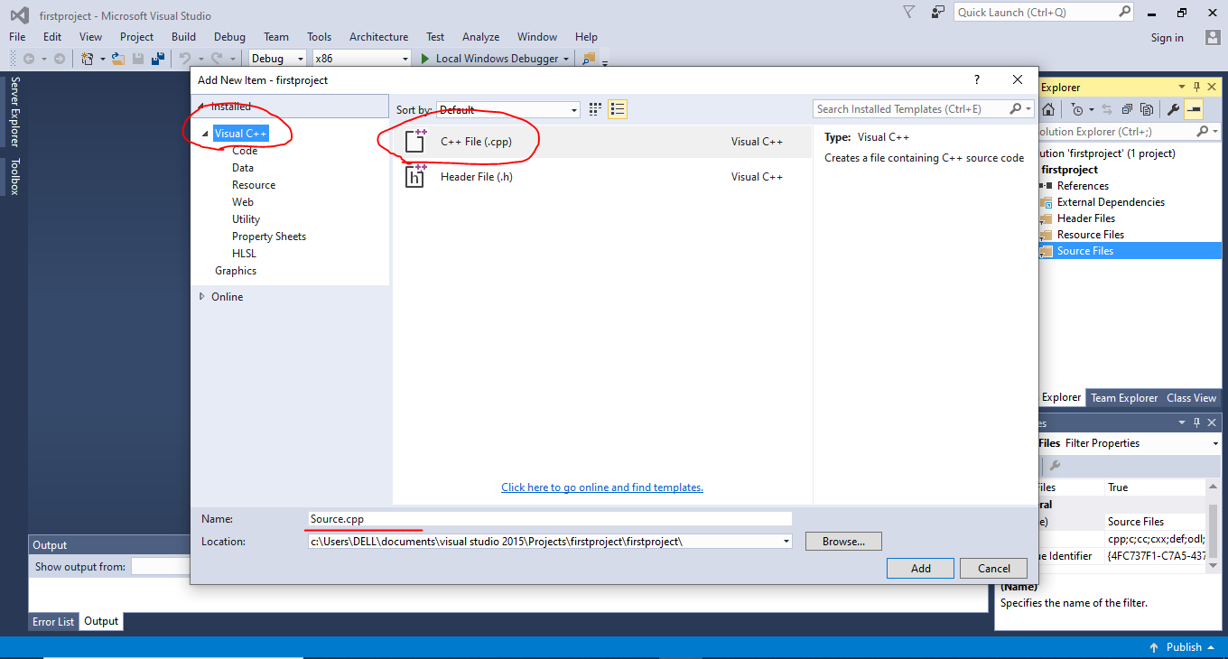

* Welcome to Visual Studio 2015. Write down your first executable program.

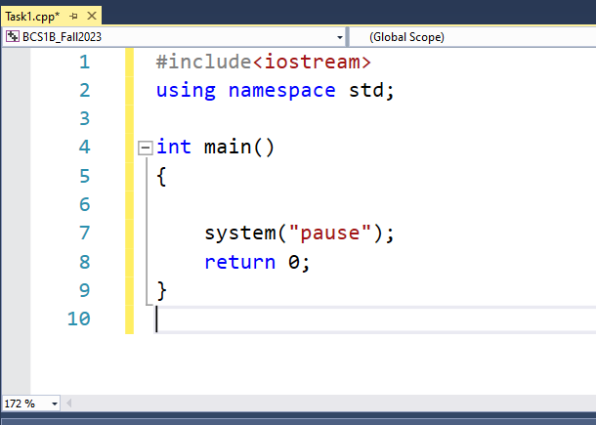

Coding Practice

**1**

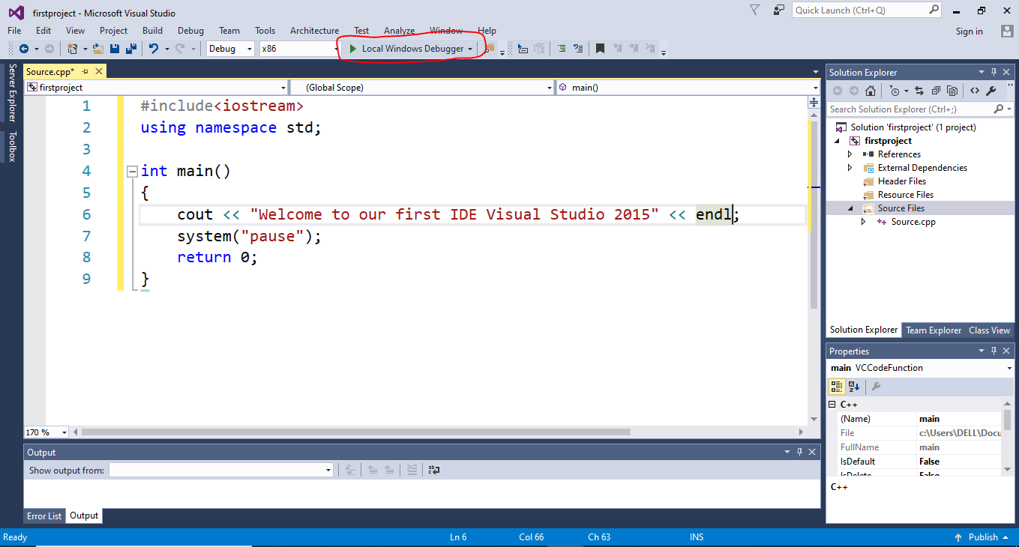

**2**

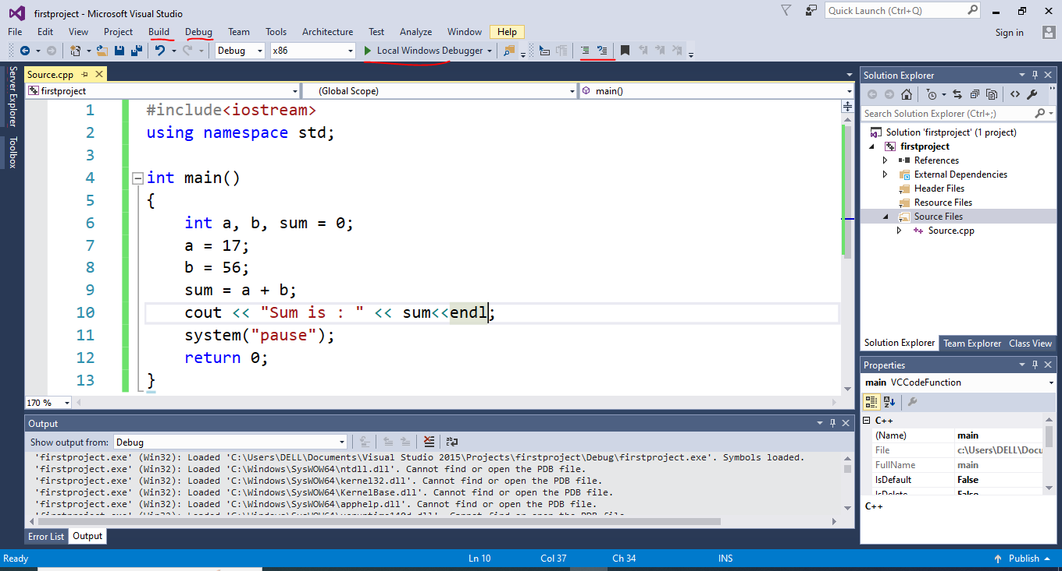

**3**

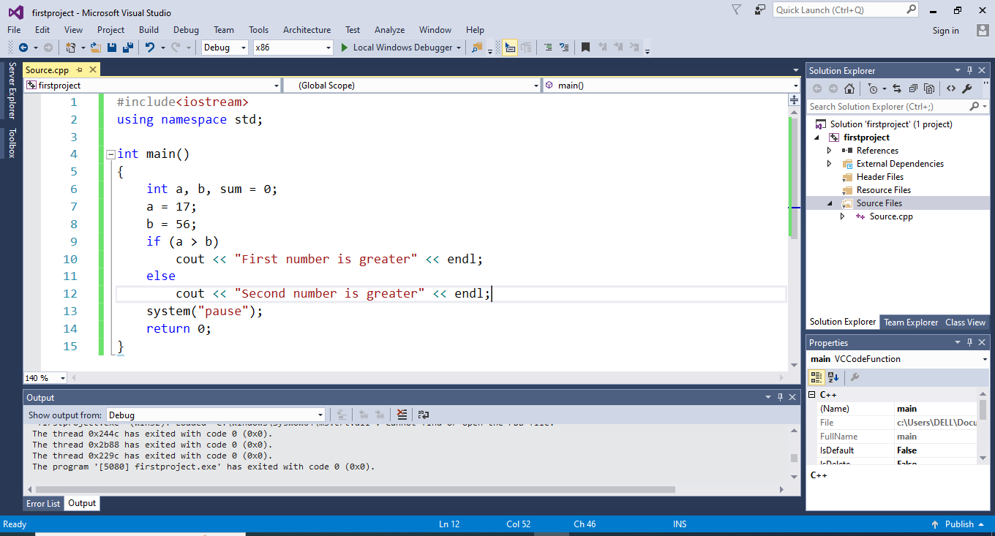

**4**

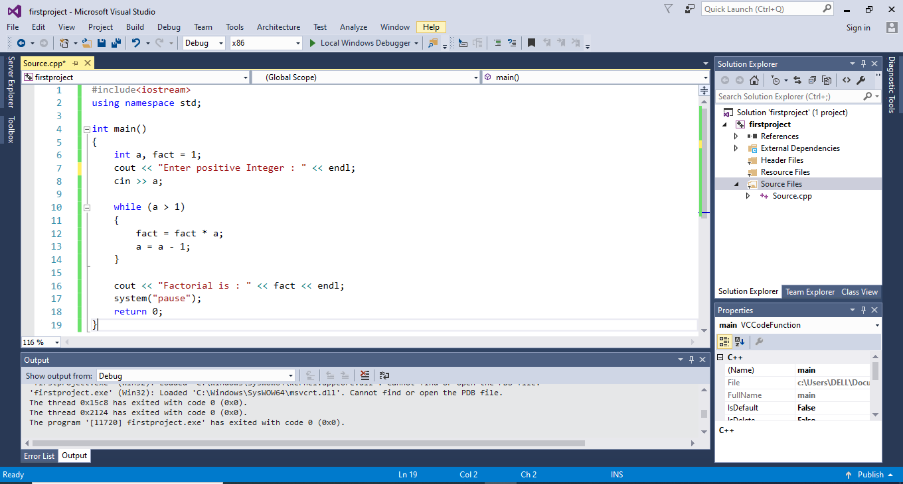

**5**

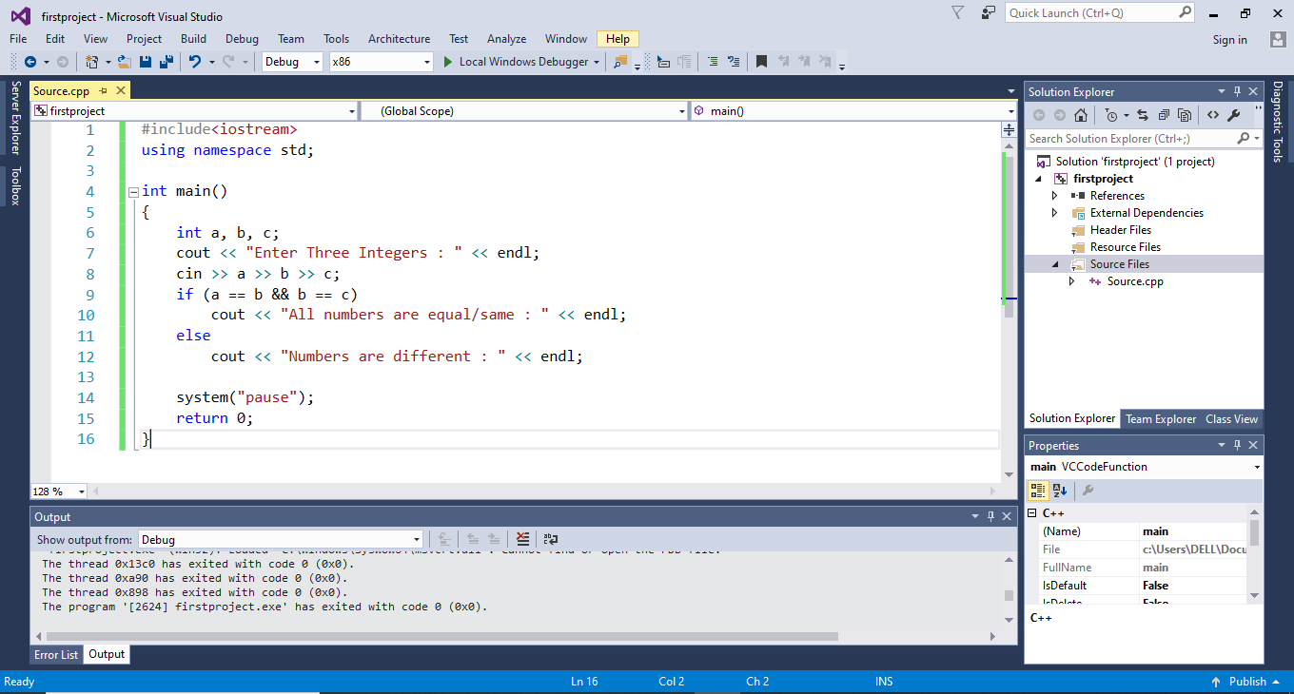

**Problem: Write C++ code for the following statements**

1. Detail understanding of Visual Studio. **(Marks 10)**

* Create Project.
* Create multiple files
* Use of comments
* Build/rebuild project
* Step-into/over
* Breakpoints
* Open an existing project from it’s loctoin.

1. J. announced some discount (flat 50%) on all its outlets. Take the original price of product from user, calculate the discounted price of one product. **(Marks 01)**

Hint: original price * discount / 100.

1. A hostelite student wants to calculate his/her average bill of the year. Take 12 inputs (bill amount) from that student and show his/her average. **(Marks 01)**

Hint: average = sum of bill/total months

1. A programming fundamental – lab consists of 10 tasks. Each task carries 5 marks. If a student solved more than 8 tasks then instructor gives him/her some extra points (5 marks additional for each task). Create a program, that asks student how many tasks he/she has solved and calculate marks.

Hint: 8*5 = 40. If extra 10 + 10 = 60 **(Marks 01)**

1. Write a program to take weather and determine the condition of weather on the following conditions: **(Marks 01)**

* Weather is greater than 45, Sunny
* Weather is greater than 20, Rainy
* Weather is less than or equal to 20, Fog
* Otherwise, False input

1. Write a C++ program to check whether a character is Vowel or Consonant. (using AND,OR operator) **(Marks 01)**
2. Write a C++ program for an activity that takes a user's input (1-7) and displays the corresponding day of the week. **(Marks 2.5)**
3. Monday
4. Tuesday
5. Wednesday
6. Thursday
7. Friday
8. Saturday
9. Sunday
10. Create a flowchart and pseudocode/algorithm to pass Programming Fundamentals - Lab.

Marks Distribution: **(Marks 2.5)**

* Lab- 40 Marks
* Final Exam- 40 Marks
* Project- 15 Marks
* Class Participation- 05 Marks
* Total- 100 Marks

Apply the grading scheme on total marks and show the relevant grades.

<30 - F

30 to 39 - D

40 to 44 - D+

45 to 49 - C-

50 to 54 - C

55 to 59 - C+

60 to 64 - B-

65 to 69 - B

70 to 74 - B+

75 to 79 - A-

80 to 85 - A

>85 - A+

---------------------------------------------------------------------------

Best of Luck 

***“Learning is never done without errors and defeat” – Vladimir Lenin***